Assessment Schedule – 2016
Mathematics and Statistics: Apply geometric reasoning in solving problems (91031)
Evidence Statement
ONE | Expected coverage | Achievement (u) | Merit (r) | Excellence (t)
(a)(i) | 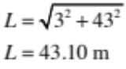 | Correctly calculates length (units not required).
(ii) | 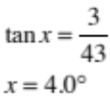 | Correctly calculates angle (units not required).
(iii) | 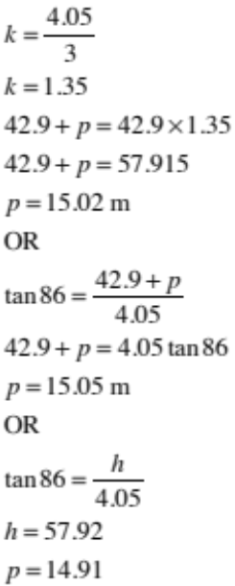  Accept with 42.9 or 43 in calculation. | Multiplies the height, h, by k (1.35).  OR  Sets up trigonometric equation correctly. | Correctly calculates p using either method.
(b) | 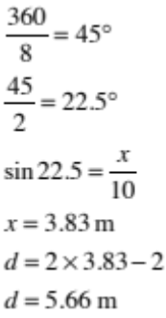 | Forming a right-angled triangle (or similar) and finding correct angle to use. | Correct calculation of x.  OR  Consistent final answer from an incorrect length in the triangle. | Subtraction of 2 m off 2x.

(c) | 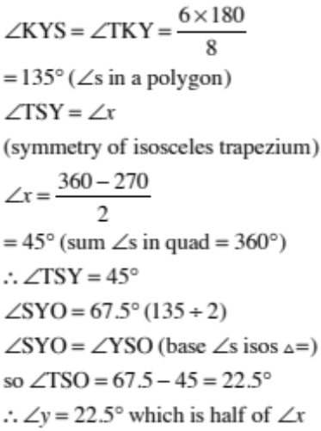 | Correctly finds angle x or y. | Correctly finds angle x or y, with reasons. | Justifies the size of the other angle with reasons.

NØ | N1 | N2 | A3 | A4 | M5 | M6 | E7 | E8
No response; no relevant evidence. | One incomplete step towards solution. | 1 of u | 2 of u | 3 of u | 1 of r | 2 of r | 1 of t | 2 of t

TWO | Expected coverage | Achievement (u) | Merit (r) | Excellence (t)
(a)(i) | ∠LDB = 90°  (BD perpendicular to LM)  ∠x = 90 – 2 = 88°  OR equivalent.  (Accept ∠’s on a line.)  AND | BOTH x and y correct.  OR  Any one angle found with correct reason. | BOTH x and y correctly found with valid reasons.
(ii) | ∠DHN = 92° (coint ∠s || lines add to 180°)  ∠ANH = ∠y = 92° (alt ∠s)  Or equivalent.
(iii) | Upper half of ∠x is 2°  (corr ∠s )  Lower half of ∠x = 6°  (∠s on st line)  So ∠x = 8°  Or equivalent.  OR  (also accept for merit)  ∠SYP = 6° (coint ∠s)  ∠SYT = 172° (alt ∠s)  (∠’s on a line)  ∠x = 8° (coint ∠s)  OR equivalent. | Angle x correct.  OR  ONE angle correct with reason. | Correct angle found with sufficient working and reasons (at least 2 of each).
(iv) | Candidate adds a line between K and L.  ∠F = 176° (∠s in a triangle)  ∠CFG = 176 (vert opp)  ∠CFG and ∠EGJ = 176  and are (corr ∠s)  Therefore AB and CD are parallel.  OR  Candidate adds a horizontal line through point F. (Label, e.g. RS.)  They then create 2 angles of 2° each.  ∠DFS = 2° (alt ∠s)  ∠JFS = 2° (corres ∠s)  ∠DFJ = 4°  and ∠JGB = 4° (∠ on a line)  ∠DFJ and ∠JBG are = (corres ∠s)  Therefore AB and CD are parallel.  OR equivalent. | Any angle correct with at least 1 reason leading towards a proof. | Any two angles correct with valid reasons leading towards proof. | Proof of parallel lines completed with valid justification.
(b)(i) | (1) Find lower height, x. Form a right angled triangle with 2° angle and hyp. length L.  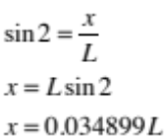  OR  x = Lcos88  OR equivalent. | Finds the lower height, x, in terms of L.

(ii) | (2) Find horizontal distance, t, between pillars.  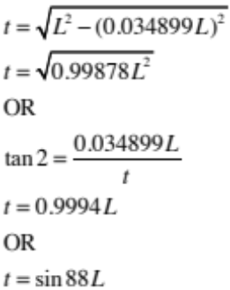  (3) Find upper height, d.  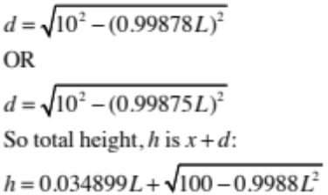 |  | Uses either trigonometry or Pythagoras to find horizontal distance, t. | Makes a consistent total height statement from finding height d and adding to height x.

NØ | N1 | N2 | A3 | A4 | M5 | M6 | E7 | E8
No response; no relevant evidence. | One incomplete step towards solution. | 1 of u | 2 of u | 3 of u | 1 of r | 2 of r | 1 of t | 2 of t

THREE | Evidence | Achievement (u) | Merit (r) | Excellence (t)
(a)(i) | ∠OQN = 19° (∠s in circle = 90°)  ∠p = 19° (base ∠s isos Δ =)  Or equivalent. | Angle p correct.  OR  1 angle shown with reason | Angle p correct with at least 2 valid reasons.
(ii) | 37 + 75 + e = 180  (opp ∠s cyclic quad = 180°)  e = 68°  Or equivalent. | Angle e correct  OR  One angle shown with reason. | Angle e correct with valid reason(s)
(iii) | ∠RON = 180 – y  (∠s on st line = 180°)  ∠ORM = 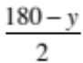 = 90 –  (base ∠s isos Δ =)  So ∠SRM = 75 + 90 – = 165 –  ∠SNO = 180 – (165 – )  = 15 +  (opp ∠s of cyclic quad = 180°)  ∴ z = 360 – 75 – (180 – y)  – (15 + )  = 90 + y – = 90 +  (∠s in quad = 360°)  OR  ∠RMO = ∠ORM =  (base ∠s isos Δ =)  z ₊ = 180  (opp ∠s cyclic quad = 180°)  z = 90 +  Or equivalent. | Finds 1 relevant angle with at least 1 reason towards proof. | Finds 2 relevant angles with at least 2 reasons towards proof. | Proof completed and well explained and justified.

(b) | 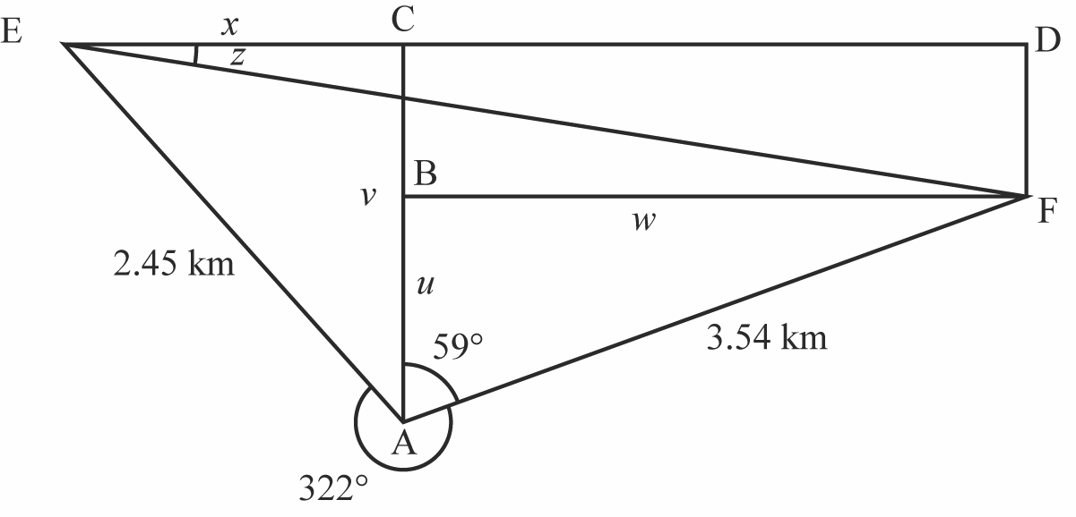  AB : cos59 = 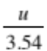  u = 1.82 km  AC : cos38 = 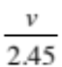  v = 1.93 km  BC = 0.11 km  BF : sin59 = 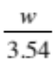  w = 3.03 km (= CD)  EC : sin38 = 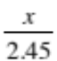  x = 1.51 km  tanz = 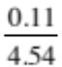  z = 1.4°  ∴ bearing is 091.4° (accept 091°) | Finds any 1 correct length using trigonometry or Pythagoras. | Finds any 3 correct lengths using trigonometry or Pythagoras. | Correct bearing found with clear reasoning and working shown.

NØ | N1 | N2 | A3 | A4 | M5 | M6 | E7 | E8
No response; no relevant evidence. | One incomplete step towards solution. | 1 of u | 2 of u | 3 of u | 1 of r | 2 of r | 1 of t | 2 of t

Cut Scores
Not Achieved | Achievement | Achievement with Merit | Achievement with Excellence
0 – 6 | 7 – 12 | 13 – 18 | 19 – 24

